**A SOFTWARE REQUIREMENT SPECIFICATION**

**ON**

**HOTEL MANAGEMENT**

**UNDER**

**NON SYLLABUS PROJECT**



**Submitted To:**

**MUSKAN KUMARI Submitted By:**

**Ishu Kumar(PIET20CS080)**

**Kaushlendra Pratap Singh(PIET20CS090) . Kalpit Sharma(PIET20CS088)**

**Designation**

**.**

DEPARTMENT OF COMPUTER ENGINEERING

POORNIMA GROUP OF INSTITUTIONS, JAIPUR

**Sotware Requirement specification (SRS)**

**Of Hotel management System**

**1**. Introduction :-

1.1 purpose

• This document is mend to dedineate the features of Hotel management .

• This hotel management system's the SRS main objectul is to provide a a basic for the Soundation of the projects .

• It gives us a view How of **"**How thy system work ? **"** & **"** What are the user & expectations **"** ?

• Clinet '& requirement are analysed to build a describe system.

1.2 scope

• The would is changing so as the scope of hotel management. To day, hotel

management is not only confined to hotels but had go deep into tourfium

catering, airling, clubs etc. making it a very promiding career option.

1.3 Defination /Abbreviation

The HMS (Hotal management system) is on online administration system used for

Reseration, Availability and occupancy management.

1.4 system overview

• The Hotel management system project of interided for Booking for booking

rooms though an online plateform our Hotel management system three end used :

• Receptionist –

Receptionist will have access to update or madifiying booking detail.

• Customers :-

Customer is able to check rooms availability.

1.5Methodology

• The method being used in developing the system is the system Development Life

Cycle (SDLC) The SDLC process includes project identification and selection,

project initiation and planning, analysis, design, implementation and

maintenance.

• The system Development Life Cycle(SDLC) is a traditional methodology used

to develop, maintain and replace or enhance information system. The main

reason SDLC model is chosen because in SDLC it is possible to complete some

activities in one phase in parallel with some activities of another phase. The life

cycle can also be interactive that is phase are repeated as required until an

acceptable system is found.

2 REQURIMENT ANALYSIS

• The main perspective of this projection in to provide a online platfrom for

Burning of notel's room with fecuse payment option & easy bone.

• This is basically similar to going hotel of booking that we have, But with the use

of computer for creating online platform .

2.1 Functional Requirements:

• The customers are able to register their details their online

• The system will record the following details of the daytomies

Registration –

Login –

Payment -

Logous -

• The customer will then gend the OTP( one time password )to verifidy the user

• Then after login customer are directed to their public profile .

• The system should display the rate for all the rooms .

• the system should display the rate for all rooms.

• the system customer r to ethire confirm or cancle there booking.

2.2 NON FUNCTION REQURIMENT

• Following non functional requriment will be their in the insurance to the

Internet :

1 sucere accesses to customer confidencial data.

2 24*7 aviability.

3 Various other non functional requriment are :-

• security .

• reliability.

• maintability .

2.3 TECHNOLOGY USED :-

• HTML.

• CSS.

• Java scripte.

2.3.1 TECHINICAL ISSUES :-

• This system will wORK On client server architecture .it will requriment an

inteater server & which will be able to run html application. The system

should support some commonly used broser such as IE ,morzzila.

3 DESINE :-

3.1 UML:-

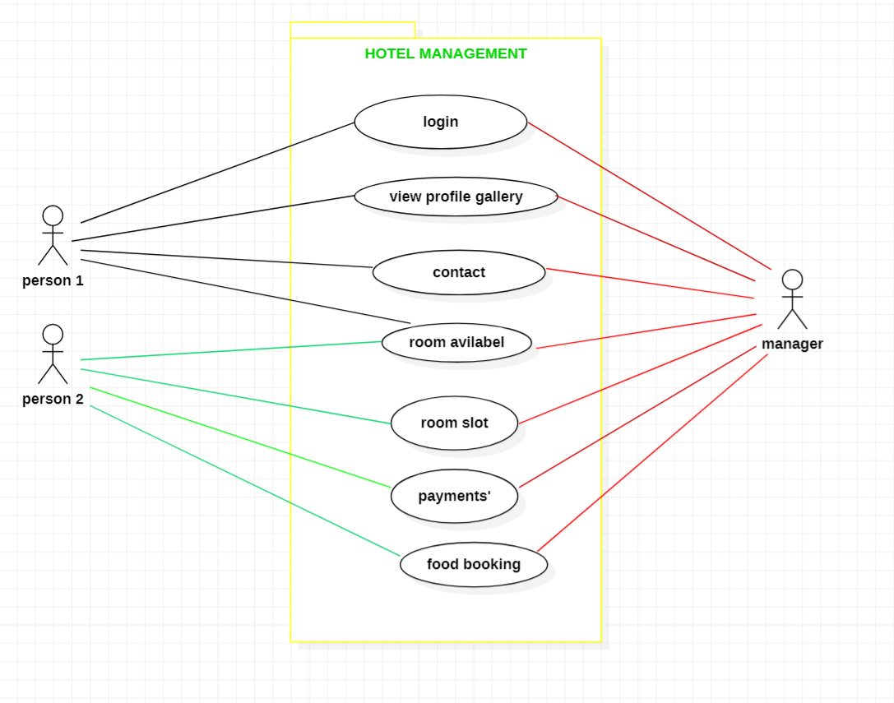

USE CASE DIAGRAM FOR HMS 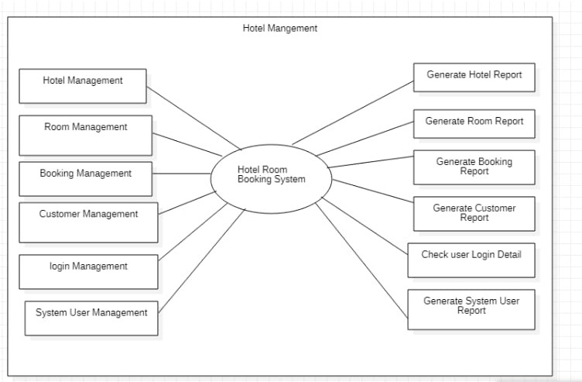

DFD FOR HMS level 1

|  |
| --- |
|  |

SNAPESHORT OF PROJECT:-

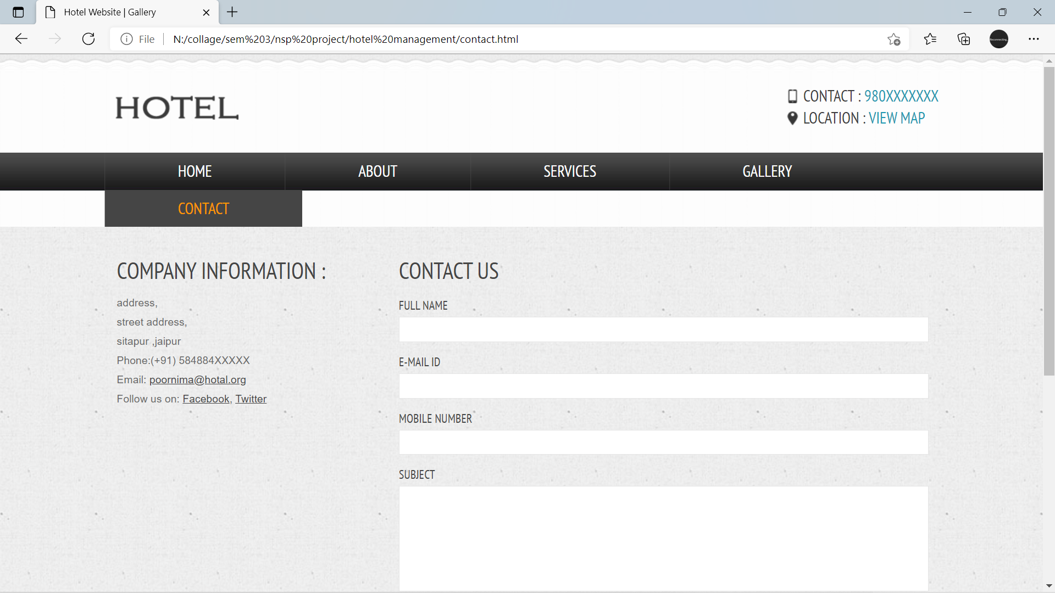

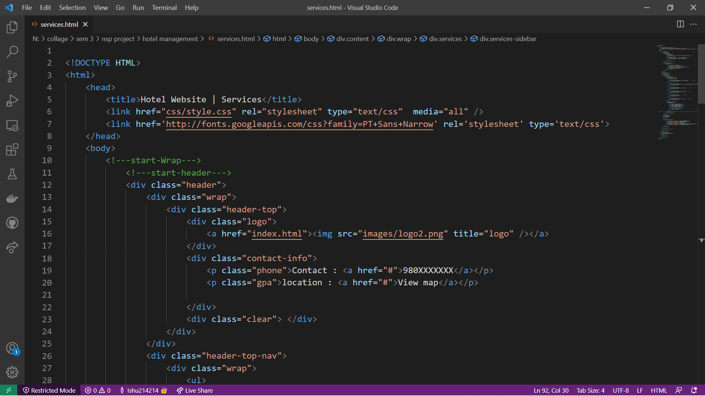

|  |
| --- |
| **DECLARATION**  I hereby declare that the Non syllabus Project report entitled “ HOTAL MANAGEMENT" was carried out and written by me under the guidance of **<MUSKAN MAM >** , Assistant Professor, Department of Computer Engineering, Poornima Institute of Engineering & Technology, Jaipur. This work has not been previously formed the basis for the award of any degree or diploma or certificate nor has been submitted elsewhere for the award of any degree or diploma.      Place: JAIPUR **KAUSLADRA PARTAP SINGH**  Date:04/12/2021  **(PIET20CS090)**  **ISHU KUMAR**  **(PIET20CS080)**  **KALPIT SHARMA**  **(PIET20CS088)** |